Aesthetics of Information Visualization
Warren Sack

Easy Information

Right now, at the beginning of the twenty-first century, there are a great number of artists working on, what could be called, projects of information visualization. "Information visualization," as a named area of research and development, was originally an outgrowth of the pragmatics of contemporary science and engineering. Faced with huge volumes of data, scientists and engineers write computer programs to render data as images making it possible to visually search for and scrutinize patterns in the data. Generally speaking, as an area of investigation and experimentation, information visualization comprises a set of tools and techniques for distinguishing the “forest” from the “trees,” for literally drawing out the big picture from a myriad of data details. It is, in short, a means for providing context.

"Mapping" data into a visual form has an obvious meaning when the data in question is geographical in nature. For example, we are all familiar with the isotherms that depict temperature differences across states or even continents and that commonly illustrate news about the weather on television and in newspapers. Less obvious is what it means to map volumes of data that have no geographical or physical "atlas" associated with them. What, for example, might a map of the stock market look like? How would one render stabilities and dynamics of the market in a manner more detailed than simply a graph of one summarizing index? Information visualization, as a scientific and technical endeavor, is now a relatively well-established sub-discipline with an annual conference (InfoVis: IEEE Symposium on Information Visualization), a prestigious journal (Information Visualization, Palgrave Publishers), and even edited collections of "classic" papers (see Card et al., Readings in Information Visualization, 1999).

Beyond the technically challenging questions of how data can be mapped are the questions of why one should map the textual or numerical into the visual. By asking why, this chapter provides an art historical and philosophical context for understanding information visualization projects undertaken as artistic research. Specifically, the question to be addressed concerns the formulation of an aesthetics of information visualization: What is the critical, artistic value of works in information visualization? Aesthetics, as a field of inquiry, examines issues of sensation and perception and seeks to understand why something is--or why some group of people finds something to be--emotionally, sensually moving. What is beautiful, ugly, awe-inspiring, emotionally overwhelming, scary or comforting? (For a contemporary overview of the field of aesthetics, see Michael Kelly (editor), Encyclopedia of Aesthetics, 1998.) So, to inquire about the aesthetics of information visualization is to investigate the judgment used to decide what about the work is valuable, according to the senses or, in general, the body.

This form of judgment--that focuses on the senses--is quite different from that usually applied in the domains of science and engineering to understand the worth of an information visualization. In science or engineering one decides on the worth of a work according to whether or not it increases the speed, accuracy or efficiency of a well-determined task (cf., Card et al., 1999). For example, a medical visualization is considered good if it helps doctors make a quicker and more accurate diagnosis.

Media theorist Lev Manovich describes artistic work in data visualization as using terms from philosophical aesthetics. Manovich writes

...data visualization art is concerned with the anti-sublime. If Romantic artists thought of certain phenomena and effects as un-representable, as something which goes beyond the limits of human senses and reason, data visualization artists aim at precisely the opposite: to map such phenomena into a representation whose scale is comparable to the scales of human perception and cognition.
Lev Manovich (2002) "The Anti-Sublime Ideal in Data Art"

While Manovich writes about a variety of artist-constructed data visualizations, we should remember that the bulk of data visualization work happens elsewhere; i.e., outside of the art world in computer science, medical and bio informatics, etc. Manovich points out that data visualization is also a project of "economists, graphic designers, and scientists." In a non-art context one might speak of the "anti-sublime" as "that which can be easily understood" or in computer-speak, one might say that many data visualization projects are an attempt to create "user friendly" interfaces to huge amounts of data. The notion of a “user friendly” interface is a utilitarian criterion of science and engineering. It coincides with the idea that the primary measure of a good visualization should be that which can assist a user to perform a task more quickly or more efficiently than the user could do without the visualization. These are, for example, the criteria applied to new interface designed when they are reviewed for the annual, international CHI (Computer-Human Interaction) conference (see http://www.acm.org/sigchi/).

Consequently, many data visualization projects can properly be called "anti-sublime." But, the neologism "anti-sublime" is understandable as within the bounds of what scientists and engineers discuss as “user friendly,” or, more simply, as “easy to understand.” This characterization of artistic data visualization as an exercise in beautiful image making to render data “friendly” or “easy” is unsatisfactory for most artists and designers concerned with information visualization. It is tantamount to an understanding that the artistic work is only an attempt to "pretty things up," i.e., to make computer images easy to understand.

The Sublime

Certainly critical alternatives to the so-called "anti-sublime" do exist and are, in fact, viable means of responding to data visualization projects, especially data visualization projects that take place within the art world. For example, one of the pieces Manovich writes about, John Simon's Every Icon (1998), is not "anti-sublime.” What this work does is exactly the opposite of the anti-sublime (see http://www.numeral.com/appletsoftware/eicon.html). It is, in fact, a meditation on the (almost) infinite that Kant describes as the mathematical sublime:

Sublime is the name given to what is absolutely great. (Kant, 1790, para. 25)

..that is sublime in comparison with which all else is small. (Kant, 1790, para. 25)

We get examples of the mathematically sublime of nature in mere intuition in all those instances where our imagination is afforded, not so much a greater numerical concept as a large unit as measure (for shortening the numerical series). A tree judged by the height of man gives, at all events, a standard for a mountain; and, supposing this is, say, a mile high, it can serve as unit for the number expressing the earth's diameter, so as to make it intuitable; similarly the earth's diameter for the known planetary system; this again for the system of the Milky Way; and the immeasurable host of such systems, which go by the name of nebulae, and most likely in turn themselves form such a system, holds out no prospect of a limit. (Kant, 1790, para. 26)

Simon's piece enumerates every possible icon of a huge series by systematically filling in a grid of 32 by 32 squares, each of which can be either black or white. It does this at a rate of several icons every second. Since there are 256 squares in the grid (32 x 32 = 256) and since each square can be “on” (i.e., white) or “off” (i.e., black) there are 2²⁵⁶ possible icons. 2²⁵⁶ is the product of a series of 256 “2”s, i.e., 2 x 2 x 2 x 2 x … (two-hundred and fifty-six times) which is approximately equal to 10 with 76 zeros following it, i.e., 1000000000….. In other words, to see literally every icon, a visitor to the gallery would have to camp out in front of the piece for billions of years! To date, after running for over seven years, only icons that use some of the first two rows of the 32 x 32 grid have been explored. This does not reduce the (almost) infinite to the easily appreciable finite: it is, I argue, an attempt at an aesthetic of the sublime, not the anti-sublime.
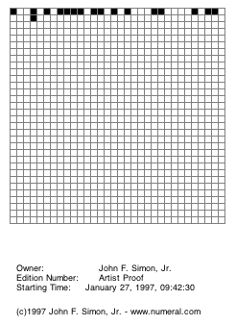
Figure 1: State of Every Icon on January 26, 2004, 18:18:30

The Uncanny

Powerful visualization projects are also often uncanny in aesthetic--yet another way of departing from the aesthetics of the "anti-sublime." To take issue with another of Manovich's analyses, I would argue that the network visualization project Carnivore (2002; see http://www.rhizome.org/carnivore/) by Alex Galloway and the RSG (Radical Software Group) collective is not successful as a project of the "anti-sublime" in the way Manovich describes it. Rather, the reason why the piece works is because it draws attention to the fact that the United States intelligence agencies make use of a piece of software (code-named Carnivore; see http://www.epic.org/privacy/carnivore/foia_documents.html) that spies on network traffic and may, indeed, be spying on you right now by scanning the email you exchange with your friends and colleagues. This fear of being profiled, of having your data copied or "doubled," the fear of the loss of or dismemberment of identity are exactly the fears that Sigmund Freud identifies with the aesthetics of the uncanny (Freud, 1919).

Carnivore is a “packet sniffer,” i.e., a piece of software that monitors the packets of information flowing through the network. The RSG has created a programming interface to the packet sniffer to facilitate the construction of various, alternative visualization programs to monitored packets. Some of these visualization programs were written by members of the RSG. Others have been written by collaborating artists who are not members of RSG (see http://www.rhizome.org/carnivore/). The visualizations constructed for Carnivore differ widely in their visual appearance.

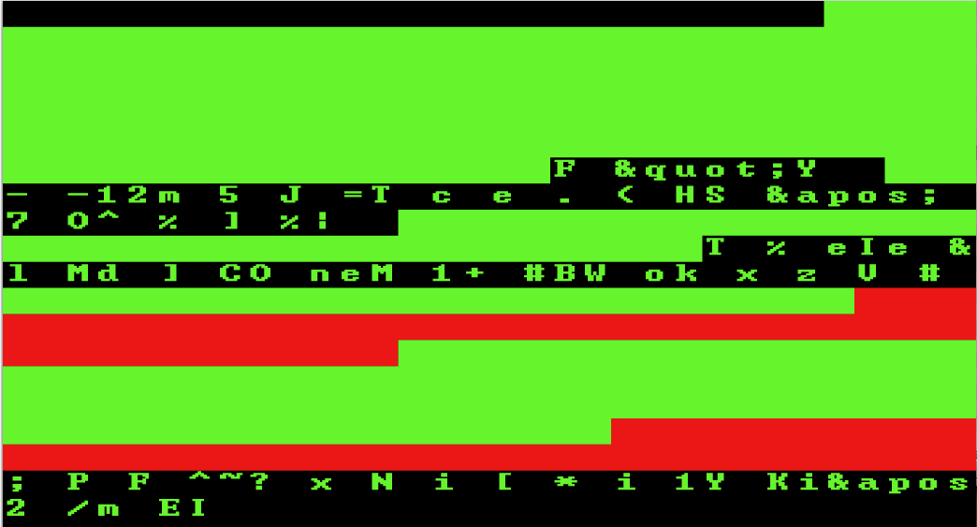
Figure 2: Carnivore client in action; see http://rhizome.org/RSG/RSG-CPE0C-1/

Artistic projects in information visualization are certainly sometimes beautiful, sometimes "anti-sublime,” sometimes sublime, and sometimes uncanny. However, even taken together, these aesthetics do not encompass the general area of creative research in information visualization. A broad enough aesthetics would have to address not only the psychological states discussed by Kant and Freud, but also the social and political implications of information visualization. If the aesthetics of information visualization are not just anti-sublime, sublime or uncanny, then what exactly are these aesthetics? I will argue that--in order to understand artistic information visualization--it is best to explore beyond Kantian and Freudian aesthetics of visual perception. My argument will be counter-intuitive because if, indeed, artistic practices have something to contribute to information visualization, then--given the term "visualization"--how could the artistic contribution come from anything other than the visual arts? I will argue that a better way to understand artistic contributions in this area is to use the ideas and methods of conceptual art rather than those of the visual arts.

Conceptual Art and the Aesthetics of Administration

The conceptual artist Sol LeWitt outlined the working methods of conceptual art using the criteria of bureaucracy:

The aim of the artist would be to give viewers information. ... He would follow his predetermined premise to its conclusion voiding subjectivity. Chance, taste or unconsciously remembered forms would play no part in the outcome. The serial artist does not attempt to produce a beautiful or mysterious object but functions merely as a clerk cataloguing the results of his premise. (Sol LeWitt, 1966)

Given this explanation, the entire notion of conceptual art sounds quite dry and tasteless. Neither is it beautiful, nor sublime, nor uncanny. Art critic Benjamin Buchloh describes this teleology of conceptual art as an "aesthetic of administration." Commenting on the above quote from LeWitt, Buchloh writes

Inevitably the question arises how such restrictive definitions of the artist as a cataloguing clerk can be reconciled with the subversive and radical implications of Conceptual Art. And this question must simultaneously be posed with the specific historical context in which the legacy of an historical avant-garde--Constructivism and Productivism--had only recently [circa 1966] been reclaimed... This question is of particular importance since many of the formal strategies of early Conceptual Art appear at first glance to be as close to the practices and procedures of the Constructivist/Productivist avant-garde as Minimal sculpture had appeared to be dependent upon its materials and morphologies. (Buchloh, 1990)

Buchloh responds to his own question of "the artist as cataloguing clerk" with a paradox:

Paradoxically, then, it would appear that Conceptual Art truly became the most significant paradigmatic change of postwar artistic production at the very moment that it mimed the operating logic of late capitalism and its positivistic instrumentality in an effort to place its autocritical investigations at the service of liquidating even the last remnants of traditional aesthetic experience. (Buchloh, 1990)

But, conceptual artist Victor Burgin provides one possible resolution to Buchloh's paradox. Burgin writes

The consolidation of conceptualist practices along the socialist lines which have been implicit from their inception demands a reading of formalist aesthetics, of history, and of current priorities, different from that now [circa 1976] predominating in the Western art community. ... We may integrate the concerns of Russian Formalism and Factography within a modern Western problematic: the first requirement of a socialist art practice is that it should engage those codes and contents which are in the public domain. These present themselves, and thus ideology, as natural and whole; a socialist art practice aims to deconstruct these codes, to unpick the apparent seamless ideological surface they present. (Burgin, 1976)

By inscribing an art history of conceptual art within a narrative that includes earlier avant-garde artists, especially those of the early-Soviet period, Buchloh and Burgin provide a means for us to understand conceptual art as a line of development within a longer genealogy of art movements concerned with contemporary modes and means of political and social production and reproduction. As outlined above, forms and procedures, as well as the existing orders under scrutiny by conceptual artists, are administrative--or perhaps more specifically--bureaucratic means of production, reproduction and distribution. Defined negatively, the aim of such artwork is against the rationalizations of bureaucracy and, thus, deductively, counter to the forms of social, political and economic formations that depend upon these rationalizations and optimizations: it is anti-capitalist and anti-authoritarian. Described positively its goals might be said to be "socialist," as Burgin described them. However, given the focus of much conceptual art on egalitarian power structures, its goals might, alternatively, be described as democratic--i.e., rule by the demos, the people, rather than rule by the bureau, the office(holders).

To recapitulate then, here is my argument. One could look at the current work on information visualization done by scientists and engineers and conclude that artists might be best equipped to make the visualizations understandable or at least prettier and easier to use. I have nothing against the idea of “user friendly” information, but I think that this understanding of artistic information visualization as the "anti-sublime" is only a small corner of a much bigger picture. In this sense, the "anti-sublime" is the project of only a small group of artist-designers who are usually referred to as scientific illustrators. Scientific illustration is only one possible role for art in the field of information visualization. The larger role for artists is best considered using the historical precedents of conceptual art. Specifically, one must consider how conceptual art has reiterated the modes of industrial production and bureaucracy in order to engage, decode and critique them.

These historical precedents, as Buchloh and Burgin make clear--include a series of avant-garde artistic movements including the early-twentieth century Constructivists and Productivists and also the conceptual artists of the 1960s and 1970s. Many of these artists were struggling with what Buchloh calls the "aesthetics of administration," i.e., the methods, means, and materials of that form of political and social production that we call bureaucracy.

Information Visualization and the Aesthetics of Administration

We can understand contemporary work in information visualization in the same way because metaphorically and literally, computers are an outgrowth of bureaucracy. Alan Turing's 1936 paper, in which the basic principles of contemporary computers are first articulated, spins an extended analogy between bureaucratic techniques (specifically writing, erasing, shifting and scanning numbers in squares on a paper tape) and the mental activities of a man:

We may compare a man in the process of computing a real number to a machine which is only capable of a finite number of conditions q1, q2, ..., qR which will be called "m-configurations." The machine is supplied with a "tape," (the analogue of paper) running through it, and divided into sections (called "squares") each capable of bearing a "symbol." At any moment there is just one square, say the r-th, bearing the symbol S(r) which is "in the machine." We may call this square the "scanned square." The symbol on the scanned square may be called the "scanned symbol." The "scanned symbol" is the only one of which the machine is, so to speak, "directly aware." However, by altering its m-configuration the machine can effectively remember some of the symbols which it has "seen" (scanned) previously. The possible behavior of the machine at any moment is determined by the m-configuration qn and the scanned symbol S(r). This pair (qn,S(r)) will be called the "configuration": thus the configuration determines the possible behaviour of the machine. In some of the configurations in which the scanned square is blank (i.e. bears no symbol) the machine writes down a new symbol on the scanned square: in other configurations it erases the scanned symbol. The machine may also change the square which is being scanned, but only by shifting it one place to right or left. In addition to any of these operations the m-configuration may be changed. Some of the symbols written down will form the sequence of figures which is the decimal of the real number which is being computed. The others are just rough notes to "assist the memory." It will only be these rough notes which will be liable to erasure.
It is my contention that these operations include all those which are used in the computation of a number. The defence of this contention will be easier when the theory of the machines is familiar to the reader. In the next section I therefore proceed with the development of the theory and assume that is understood what is meant by "machine," "tape," "scanned," etc. (Turing, 1936-1937, p. 231-232)

The "files," "directories," "folders," and "volumes" of contemporary operating systems; the "tables" and "entries" of database systems; the "rows" and "columns" and accounting procedures of spreadsheets; the common algorithms of "sorting," "queuing," and "categorization" all are reminders of the bureaucratic lineage of the computer and computer science, in general. Most graphically, consider the standard, contemporary, computer interface--based on the so-called "desktop metaphor." This interface was developed as an extended analogy with the furniture, artifacts, and filing techniques of the office--i.e., cutting, pasting, throwing things in the trash. (See, especially, Engelbart, 1962; and, Engelbart and English, 1968).

But, if conceptual art of the 1960s and 1970s was against the mindset and materiality of bureaucracy, and if contemporary artistic work in information visualization can be understood as against the bureaucratic machinery of today, what exactly might be meant by “the opposite of,” or “opposition to,” bureaucracy? To investigate this idea of opposition, it is useful to consider the word literally. "Bureaucracy" is literally constituted from "bureau"--the office--plus "-cracy"--a term that means governor; thus, "bureaucracy" means government via the office, its techniques and organizations. These techniques and organizations were originally developed, especially, in the eighteenth and nineteenth centuries for the requirements of then-new, large-scale social, political, and economic formations, like the nation-state and advanced forms of capitalism. Consider Max Weber's concise statements on the "characteristics of bureaucracy.
Modern officialdom functions in the following specific manner:
- There is the principle of fixed and official jurisdictional areas, which are generally ordered by rules, that is, by laws or administrative regulations.
- The regular activities required for the purposes of the bureaucratically governed structure are distributed in a fixed way as official duties.
- The authority to give the commands required for the discharge of these duties is distributed in a stable way and is strictly delimited by rules concerning the coercive means, physical, sacerdotal, or otherwise, which may be placed at the disposal of officials.
- Methodical provision is made for the regular and continuous fulfillment of these duties and for the execution of the corresponding rights; only persons who have the generally regulated qualifications to serve are employed [emphasis added]. (Weber, 1979)

In opposition to this are a variety of other forms of governance. Rather than governance by the office and officeholders, the focus of much conceptual art has been on more egalitarian power structures. Its goals might, therefore, be described as democratic--i.e., rule by the demos, the people, rather than rule by the bureau, the office(holders).

My argument in a nutshell is this: when you look at artistic projects that map out and visualize information, do not worry so much about whether they are pretty, beautiful, friendly or easy to use. Instead interrogate them by asking what sorts of governance they support or reflect: Are they democratic or bureaucratic? In short, I ask that we shift our attention away from visual aesthetics and focus, instead, on an aesthetics of governance.

Aesthetics of Governance and Self-Representation

There is (at least) an aesthetics of beauty, of the anti-sublime, of the sublime, of the uncanny and of administration. What is aesthetics if it is so flexible that it can be stretched around such a heterogeneity? Terry Eagleton reminds us that the focus of aesthetics was, at least historically, on the body:

Aesthetics is born as a discourse of the body. In its original formulation by the German philosopher Alexander Baumgarten, the term refers not in the first place to art, but, as the Greek aisthesis would suggest, to the whole region of human perception and sensation, in contrast to the more rarefied domain of conceptual thought. (Eagleton, 1990, p. 13)

An aesthetics of governance concerns a different corpus, a different body, than the body of the individual subject posited by a Kantian aesthetics. The “body” of an aesthetics of governance is a “body politic,” a collective, a Leviathan constituted from a group of people articulated together through a diverse set of social and technical means. The philosopher Thomas Hobbes expanded on this metaphor of a "body politic" in his book Leviathan (and, strangely enough, arrived at very anti-democratic conclusions):

For by art is created that great Leviathan called a Commonwealth, or State (in Latin, Civitas), which is but an artificial man, though of greater stature and strength than the natural. (Hobbes, 1651)

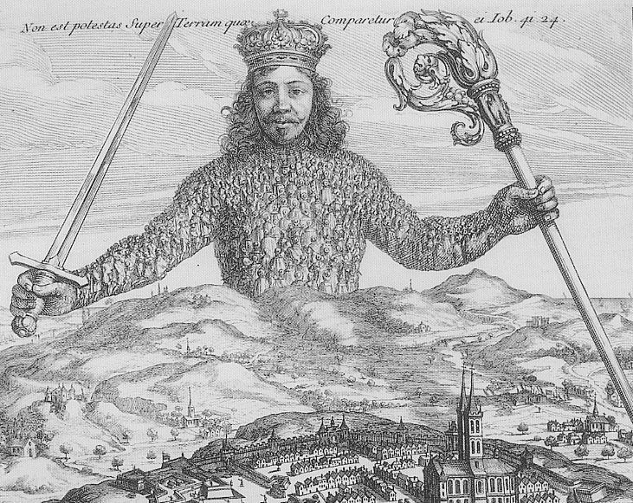
Figure 3: Frontispiece of the 1651 edition of Thomas Hobbes’ Leviathan illustrated by Abraham Bosse, graphically represents Hobbes’ conception of the Commonwealth

The "art of governance," the means to steer or navigate or orient the collective body, has of course been the subject of centuries of work in political science and at the center of, for example, modern research projects like cybernetics. "Cybernetics" is a term which, itself, comes from the ancient Greek word kubernhthj meaning steersman or governor. The inventor of the term, Norbert Wiener, was acutely aware of contending models of governance and politics and worked closely with labor unions to examine the politics of industrial automation (Wiener, 1985). In the contemporary and the ancient world “art of governance” is not, and has not been, simply concerned with the perception of and representation of only things, or objects, but rather the interpretation, organization, articulation and representation of subjects, specifically the representation of people and things woven together.

When artists work together in groups or collectives, the art of governance is often practiced as a response to a collective need to organize and guide the group. Craig Saper has called this sort of art practice "intimate bureaucracy." According to Saper, "intimate bureaucracies" have been designed to mimic, comment on, and appropriate bureaucracy for local needs:

Intimate bureaucracies monitor the pulse of the society of the spectacle and the corporatized bureaucracies: economics as in Big Business, culture as in Museums and Art Markets, mass media as in Studio Systems and Telecommunications Networks, and politics as in Big Government. Rather than simply mounting a campaign against big conglomerations of business, government, and culture, these artists' networks and their publications use the forms of corporate bureaucracies for intimate ends. (Saper, 2001, p. 24)

In short, this form of art practice--the appropriation and détournement of bureaucracy--can be immediately practical for the collective needs of artist groups. We see this practice in older conceptual art work and newer information visualization work applied to online archives of art work. For example, in 2002, Rhizome.org at the New Musuem, New York (see http://rhizome.org) commissioned several artworks to serve as graphical interfaces and visualizations to the large database of online artworks stored at rhizome.org. Artist Lisa Jevbratt's work Troika was one of the 2002 commissions:

The Web in general, and the Rhizome community in particular, is an environment for discussion and exchange. The actions we take, the pages we visit, and the objects we select are all ways of expressing and sharing our views and ideas. The Troika interfaces make this explicit by generating mappings of the database that are dependent on the activities of its users.
The Troika interfaces display each object in the Rhizome database as one pixel--the object is accessed by clicking on the pixel. The pixel's color represents the keywords that are associated with the object and the people that have requested it in relation to a specified troika--a conceptual triad such as "body, mind, spirit." The color that represents the object is changed over time as a result of users making traces in the database. The users are marked with the color of the object they first select, and leave a trace of that color on the objects they select afterwards. The interfaces are animated to show the colors changing over time. http://rhizome.org/commissions/troika.php

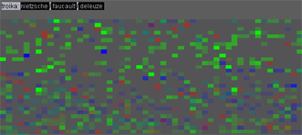
Figure 4: A screenshot of Lisa Jevbratt's Troika visualization of the rhizome.org art database (http://rhizome.org/commissions/troika.php)

The aesthetics of governance apparent in Jevbratt's visualization of online discussion and exchange is an outgrowth of a genealogy of conceptual artwork on indexing, tabulating, and visualizing discussion and exchange between artists. The term "troika" is etymologically Russian and means an administrative or governing body of three.

In the 1970s, the conceptual art group Art & Language produced a series of related projects that can serve us to better understand contemporary, information visualization work, such as Jevbratt's project.

Index 01 by Art & Language

Indexing problems...are coincident with the difficulties encountered in mapping the space in which our conversation takes place. (Atkinson and Baldwin, 1972, p. 16)

The conceptual art group Art & Language was invited to participate in the 1972 Documenta 5 exhibition. The work they created for the exhibition was entitled Index 01. It comprised eight metal filing cabinets filled with documents and arranged according to a posted index designed to articulate the relationships between eighty-six texts authored by Art & Language.

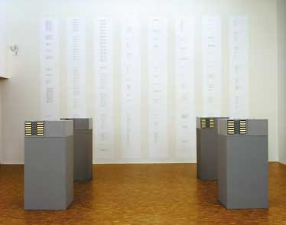
Figure 5: Index 01, 1972; Dimensions variable. Collection Daros, Switzerland.
Photo: Matthieu Langrand, Lille.

The index related each text to the others using one of three possible relations symbolized as "+" (to indicate that two texts where compatible); "-" (to indicate that the texts were incompatible); and "T" ("signifying that the relevant documents did not share the same logical/ethical space and were therefore not to be compared in advance of some notional transformation," Harrison, 1991, p. 65). This index was rendered as a "map" (entitled, by Art & Language, "Alternate Map for Documenta") consisting of a table in which each text was noted on the top and left hand side of the table and the relationships between each pair of texts was entered in the eighty-six rows and columns. Each text was given a letter from (i.e., A, B,..., Z, A', B',..., Z', A'', B'',...Z'', A''', B''', ...,I'''). The first ten rows and columns of the map-table looked like this:

A B C D E F G H I J
A + T T T + T + + + T
B T + - - T - T T T -
C T - + - T - T T T -
D T - - + T - T T T -
E + T T T + T + + + T
F T - - - T + T T T -
G + T T T + T + + + T
H + T T T + T + + + T
I + T T T + T + + + T
J T - - - T - T T T +

Logically, each text is considered to be compatible with itself and so the diagonal of the table is filled with "+"s.

This work by Art & Language (which was reproduced as a poster) was motivated by a specific, practical need. One of the main productions of the group was a set of writings (many of which were published in their journal Art-Language). As the group increased in size and these writings grew in number, it became necessary to find a form that could be used to exhibit the collective work of the group. Charles Harrison, a member of Art & Language and an editor of the journal Art-Language, described the group's imperative like this:

The adoption of the index as the means to map and to represent relations within a conversational world was in part a consequence of the enlargement of Art & Language itself. ... Through the forum of Art-Language and through less formal means of exchange, a habit of correspondence and conversation developed rapidly if unevenly between members of this extended group and their various interested affiliates. By the spring of 1972 a substantial corpus of written material had accumulated, addressed to range of issues which was not easily circumscribed, but which seemed in need of some form of identification, if only so that the identity of the association itself might be reviewed by those who saw themselves as composing it. (Harrison, 1991, p. 63)

This description of Index 01 accords with Saper's definition of an "intimate bureaucracy." It is an example of the techniques of bureaucracy employed for the intimate purposes of a small group of artists. The production of the tools of bureaucracy--reference works, indices, collections and libraries of shared resources and multiple-author works--has been undertaken by a variety of artist groups for intimate purposes. For example, the Surrealists compiled a number of “dictionaries” (e.g., Breton and Eluard, 1938; Leiris, 1939; Corvin, 1966). This practice has been continued by contemporary art groups like the “Concise Lexicon for the Digital Commons” (2001) written by the Raqs Media Collective (Jeebesh Bagchi, Shuddhabrata Sengupta and Monica Narula; see http://www.sarai.net/compositions/texts/works/lexicon.htm). More diverse collections were compiled by the Fluxus art group in the 1960s. For example, the collection Fluxus 1 was seventeen manila envelopes containing various items, bound together with aluminum bolts, with pages of text, music and artwork interspersed, issued in a wooden box (Maciunas, 1964). Artworks of collecting, organizing, indexing and archiving the heterogeneous, the mundane and the extraordinary were highlighted in a 1998 exhibition entitled Deep Storage: Collecting, Storing and Archiving in Art held at P.S. 1 Contemporary Art Center in New York City (Schaffner and Winzen, 1998). Works like these and others provide the means and opportunity to reflect on and describe the limits and interrelationships of the many works produced by members of a group.

Clearly, however, Index 01 was not only the practical result of a functional design created in response to a utilitarian need. The form of the Index was also a response to the cultural conditions of another art movement, Minimalism, and the wider environment of the machinery of business and information:

The principal design decision was that the appearance of the indexing-system should be made compatible with the appearance of other indexing-systems--and not prima facie with the appearance of other works of art. If this suggests that the Index was redolent rather of the office or the library than the art gallery or the museum, it should be borne in mind that metaphorical assimilation of the one form of location to the other was by 1972 an established stylistic tactic of avant-garde art. It was a cultural condition of Minimal Art, and of Minimalism, that powerfully suggestive forms of the iconography of modernity were generated by the furniture of multinational business and by the technology of information storage and retrieval systems. These were symbolic of that non-aesthetic world with which any modern art with pretensions to realism was required to engage at some level, and in the face of which--whatever the pretended voluntarism of artists in the sphere of design--it was required to establish its autonomy. (Harrison, 1991, pp. 67-68).

Here then we have a confluence of three criteria that informed the shape and function of Art & Language's Index 01: (1) a practical need for governance, orientation and navigation to create an archive, visualization, and filing system for the group; (2) an artistic need to respond to the visual forms of contemporary art; and, (3) a cultural need to comment on, critique, provide alternatives, and distance the group from the bureaucratic forms and procedures of modernity, especially those of information technologies, government practices, and hegemonic business tools and ideas.

Corpora: The Bodies of Information Visualization Aesthetics

The corpus, the body of works, that Art & Language organized and visualized with its Index 01 was a self-defined one. The forms and formats of bureaucracy employed by Art & Language--the filing cabinets, the index cards, the tables of numbers and letters--were used towards what Saper calls an "intimate bureaucracy." Jevbratt's Troika is a similar reuse of the forms of contemporary bureaucracy (no longer the filing cabinet and index card, but the database and spreadsheet) for other means, for artistic goals, for the archive and interface to the body of works stored by Rhizome.org: the corpus of online artworks in its database. While the works incorporated by Index 01 are more intimate--simply because they specifically concern the immediate members of the Art & Language group and the works at Rhizome.org encompass productions of thousands of artists--Index 01 and Troika are comparable because the bodies of works they engage are comparable: they are both collections of artworks.

The criteria of Art & Language suggest a means for exploring the aesthetics of artistic information visualization: we need to look at the corpora, the bodies, that are engaged and how these bodies are articulated, challenged, and represented by the visualizations. Information visualization is an attempt to index and articulate these bodies which--despite the often-asserted idea that digitally-stored information can be infinitely reproduced--are constantly at risk due to disk crashes, miniaturization, noisy networks, and, in general, disappearance. These bodies are under threat of destabilization, dematerialization, and disembodiment.

Writing about databases, data visualization and mapping, Christiane Paul makes the following observation about embodiment and materiality in the digital age:

In the digital age, the concept of "disembodiment" does not only apply to our physical body but also to notions of the object and materiality in general. Information itself to a large extent seems to have lost its "body," becoming an abstract "quality" that can make a fluid transition between different states of materiality. (Paul, 2003, p. 174)

Paul's diagnosis is acutely accurate and yet troubling in these contemporary, cultural circumstances where a loss of the body is oftentimes promoted as a benefit of information technologies. The central artistic, aesthetic focus on the body is in sharp contrast with the scientific and engineering pragmatics that dematerialized the body over the course of the invention and development of contemporary information technologies. In a history of cybernetics and information technologies, Katherine Hayles shows how the dematerialization and disembodiment of information was seen as a good thing and explicitly pursued as a line of scientific research and development (Hayles, 1999).

In works like Jevbratt's Troika and Art & Language's Index 01, the body-in-question is, discretely, a body of artworks. But the body-in-question for Alex Galloway and RSG's Carnivore implies a larger constituency: it is those of us who might be targeted by the intelligence agencies. Carnivore's implied body-in-question is therefore one of the larger, collective, sociopolitical bodies--the Leviathans or the self-governing bodies of democratic societies--that are under not only the threat of de-coupling or dissection but the threat of erasure and disappearance.

The genealogy of information visualization work includes the collection of work done by artists and designers throughout centuries to make these collective bodies visible and give them the means to assemble and connect. There is a specific lineage of this work devoted to the demos, the creation of spaces, places and representations for the Body Politic of democracy.
In a paper subtitled "The Invention of the Impossible Body Politic," Bruno Latour examines this genealogy of art and design created for the Body Politic of the demos. Latour focuses on Socrates' anti-democratic position in Plato's Gorgias:

All the centuries of arts and literature, all the public spaces--the temples, the Acropolis, the agora--that Socrates is denigrating one by one, were the only ways the Athenians had invented to reflexively seize themselves as a totality living together and thinking together. We see here the dramatic double-bind that turns the Body Politic into a schizophrenic monster: Socrates appeals to reason and reflection--but then he deems illegitimate all the arts, all the sites, all the occasions where this reflexivity takes the very specific form of the whole dealing with the whole. He decries the knowledge of politics for its inability to understand the causes of what it does, but he severs all the feedback loops that would make this knowledge of the cause practical. No wonder Socrates was called the numbfish! What he paralyzes with his electric sting is the very life, the very essence of the Body Politic. (Latour, 1997, pp. 218-219)

In other words, the aesthetics of information visualization concerns the Body Politic and the history of information visualization is the history of art and design created to gather together, reflect and represent the Body Politic. Its history includes the history of public spaces, the arts, and literatures representative or supportive of the Body Politic.

Incorporating the Little Guy into the Democratic Body

If the Body-Politic-in-question is representative of democratic politics, then a simple reflection (e.g., a group portrait) or an ironic appropriation of the tropes of administration (e.g., an intimate bureaucracy) is not good enough for the needs of democracy. In an essay on mapping and information visualization, Steve Dietz explains the more demanding criteria of democratic maps and visualizations by posing two questions:

Is there a way to create a wider base of experience without becoming prescriptive; to honor the individual point of view while ending up with an overall point of view that has value for more than the participants? (Dietz, 2004)

Dietz poses these questions as a means to describe the criteria fulfilled by two data visualization projects. The first, produced by Julie Mehretu and Entropy8Zuper!, Minneapolis and St. Paul Are East African Cities (2003) is a website that functions as a map of the life stories of East African immigrants living in the Twin Cities.

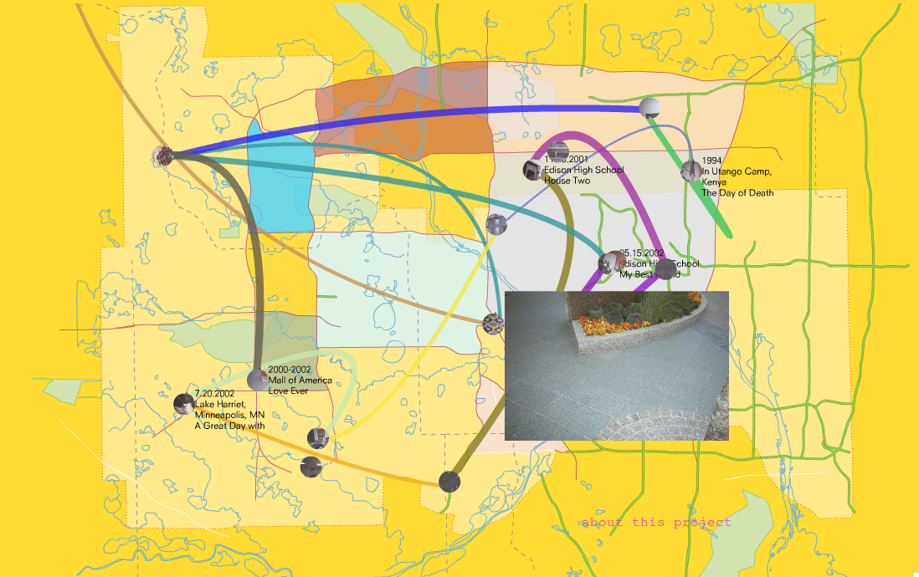
Figure 6: A screenshot from Minneapolis and St. Paul are East African Cities: http://tceastafrica.walkerart.org/

The second project, PDPal (2003) was done by Scott Paterson, Marina Zurkow, and Julian Bleecker. PDPal is a mapping tool for recording personal experiences of public space. Using a PDA one can browse and record stories and then upload them to a website. The website is a visual interface to personal stories recorded in Manhattan and the Twin Cities.

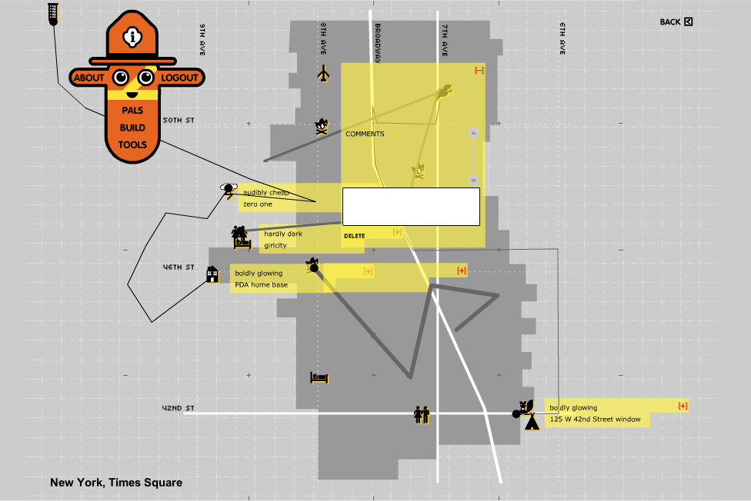
Figure 7: A PDPal map for New York City, Times Square: http://pdpal.com

Both of these projects, East African Cities and PDPal, propose visual means for answering Dietz's questions. In fact, they both contain answers to the question implicit in Dietz's use of "homunculus" in his title: how, in the representation of the collective Body Politic, can the small, independent voice, the little person, the homunculus be given place? And, simultaneously, how can this place be more than a cog in a giant machine? Furthermore, how can the means of articulating people together be more than an industrial machine or a post-industrial, bureaucracy? All of these are questions at the core of an aesthetics of information visualization. As Terry Eagleton puts it:

The construction of the modern notion of the aesthetic artefact is thus inseparable from the construction of the dominant ideological forms of modern class society, and indeed from a whole new form of human subjectivity appropriate to that social order. (Eagleton, 1990, p. 3)

An Art of Networks: Not An Art of Territories

The response to these questions provided by both East African Cities and PDPal is largely conventional and shared by other projects based on geographical information systems (GIS): individuals are given place on a geographical map. In the case of East African Cities the map we, the viewers of the piece, see is a map of Minneapolis and St. Paul. Contributors to the map place audio clips, videos, photos, and other representations of their personal stories on the map. Similarly, contributors to PDPal position their own work on a map of Manhattan or the Twin Cities. True, this can provide a place, a position, for everyone in the larger Body Politic. But, this Body Politic, based on geography or territory, is a very old one that is more nostalgic than functional in the contemporary, network society (cf., Castells, 1997, p. 60). As Michel Foucault pointed out, the art of governance ceased to be practiced strictly on geography and was conceived of as a network already by the eighteenth century. In the eighteenth century the object of government moved away from the preservation and expansion of a principality to a semi-abstract, statistically described population. Foucault indicates that the first steps towards this shift in the object of government was detailed in the sixteenth century in a work by Guillaume de La Perrière, Miroir Politique (1567):

...in La Perrière's text, you will notice that the definition of government in no way refers to territory. One governs things. I do not think this is a matter of opposing things to men, but rather of showing that what government has to do with is not territory but rather a sort of complex composed of men and things [emphasis added]. The things with which in this sense government is to be concerned are in fact men, but men in their relations, their links, their imbrication with those other things which are wealth, resources, means of subsistence, the territory with its specific qualities, climate, irrigation, fertility, etc.; men in their relation to that other kind of things, customs, habits, ways of acting and thinking, etc.; lastly, men in their relation to that other kind of things, accidents, misfortunes such as famine, epidemics, death, etc.
(Foucault, 1991, p. 93)

This "government of things" or government of heterogeneous assemblages of people and things sounds a lot like what Bruno Latour has called a "Parliament of Things" (Latour, 1993) or the "network society" as described by Manuel Castells (Castells, 1997). But, the eighteenth century developments that Foucault details precede Latour’s and Castells’s observations and include a series of record keeping devices (e.g., the tables and taxonomies of government) and calculations (the invention of statistics; cf., Hacking, 1991) that ultimately led to what Foucault calls the "art of government" or--more idiosyncratically--governmentality. These foundations of the art of government are what allows for the development and governance of large centralized nation-states as a statistically created "population." And, it is within this lineage that political scientists--like Oscar Gandy (1993) and his colleagues--find an emerging, computerized surveillance: what Gandy calls the panoptic sort. In short, Gandy et al. see computerization as the latest form of bureaucracy and governmentalization: a new means to artificially, statistically constitute a population for centralized control.

But, as William Shakespeare made clear hundreds of years ago, it does not take an array of computers to organize a Body Politic under centralized control--it does not even require a bureaucracy.

This Realm of England is an Empire..governed by one supreme Head and King..unto whom a Body politick, compact of all Sorts and Degrees of People..been bounden and owen to bear a natural and humble Obedience.
William Shakespeare (1532-3) Act 24 Henry VIII, xii.

Consider the topology of Henry VIII’s Empire as a network: it is a “star.” I.e., it is a network with one center (the King) and many “rays” or “spokes” populated by “all Sorts and Degrees of People”; i.e., the “Body politick”. The current fears of surveillance--the uncanny feeling of works like the RSG collective’s Carnivore--are fears that the new technology will be a re-incorporation of a centralized, “star” network in which a small group of people will exert direct control over the rest of the Body Politic. To imagine that technologies--like those of information visualization--autonomously produce Machiavellian nightmares--like the “star” network--is a mistake. It is a mistake made when one forgets the art of self governance.

The art of democratic governance is not the same as a tyrant’s art of governance. A democratic art must reimagine the topology of couplings within the Body Politic as rhizomatic--as multiple and heterogeneous interconnections between people and things that facilitate a self-governance--a governance without a tyrant at the center. Technological innovation to support this vision contributes to, what Michel Foucault has called, a “technology of the self,” (Foucault, 1997, p. 225): a technology designed and practiced to support self-governance. This is the problem for a democratic aesthetics of information visualization.

Visualizing the Bodies Politic of Social Software

The development of new technologies for self-governance are increasingly being developed under the rubric of “social software.” MoveOn.org, Meetup.com, Friendster.com, IndyMedia.org, weblogs, CVS (Concurrent Versioning System), and SMS (Simple Message Service) are just a recent sampling of new technologies that provide people with opportunities to meet, play and work together.

Some of these do not require any sort of visualization to provide participants with an image of the large Body Politic into which they are incorporated because the technologies facilitate emergent, face-to-face meetings; or, what author Howard Rheingold has termed “smart mobs” (Rheingold, 2002). For example, in January of 2001, the President of the Philippines , Joseph Estrada, was overthrown by a “civilian-backed coup” now known as “People Power II.” Estrada’s impeachment trial was unexpectedly and abruptly ended by eleven senators believed to be under Estrada’s influence. In response, hundreds of thousands of citizens protested in the streets largely self-organized through the use of SMS messages sent via cell phones (Rafael, 2003). This self-organized, self-governed Body Politic was brought together, face-to-face as a crowd on the streets. As a member of the crowd, we do not necessarily need to visualize it, we can see and feel the rest of the crowd.

But, when the body of people is brought together in a mediated space, rather than in physical space, then information visualization provides a means for seeing both the demos and the tyrants. The site TheyRule.org by artist Josh On, of Futurefarmers (http://www.futurefarmers.com), is a good example of the latter. The site is described like this:

They Rule aims to provide a glimpse of some of the relationships of the US ruling class. It takes as its focus the boards of some of the most powerful U.S. companies, which share many of the same directors. Some individuals sit on 5, 6 or 7 of the top 500 companies. It allows users to browse through these interlocking directories and run searches on the boards and companies. http://www.theyrule.net/html/about.php#overview

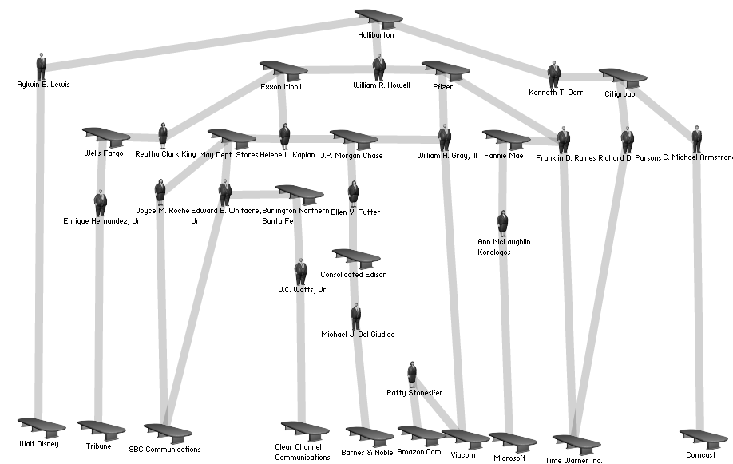
Figure 8: A They Rule map of “Haliburton and the Media [top-down]” (http://www.theyrule.net/2004/tr2.php)

Seeing the assembled, mediated demos, a democratically constituted Body Politic, is as necessary for participants engaged in e-democracy as seeing the rest of the crowd is necessary to those who assemble on the street (with or without cell phones). “Seeing” the assembled, mediated Body Politic is not a new problem. For example, counting the votes cast in a national election is one, simple form of understanding the coalitions and divisions constitutive of a non-local Body Politic. Discovering or inventing a visual form to show the Body Politic itself to itself is the outstanding problem of artistic research in information visualization. As a part of a larger Body Politic in a democratic society we need to see ourselves and our imagined communities (Anderson, 1983) within our larger political and cultural contexts.

References

Benedict Anderson, Imagined communities: reflections on the origin and spread of nationalism (London: Verso, 1983).

Terry Atkinson and Michael Baldwin, "The Index," in The New Art (exhibition catalogue, Arts Council of Great Britain, Hayward Gallery, London, August 1972), p. 16.

Andre Breton and Paul Eluard (Editors), Dictionnaire abrégé du surréalisme (Paris: Galerie Beaux-Arts, 1938).

Benjamin Buchloh, "Conceptual Art 1962-1969: From the Aesthetic of Administration to the Critique of Institutions," October 55 (1990).

Victor Burgin, "Socialist Formalism," Studio International, 191:980 (March-April 1976) 148-52.

Stuart Card, Jock D. Mackinlay, Ben Schneiderman (Editors), Readings in Information Visualization: Using Vision to Think (San Francisco, CA: Morgan Kaufmann Publishers, 1999)

Manuel Castells, The power of identity (Malden, MA: Blackwell, 1997)

Michel Corvin (Editor), Petite folie collective (Paris: Tchou, 1966).

Steve Dietz, "Mapping the Urban Homunculus," in ELSE/WHERE: MAPPING, edited by Janet Abrams and Peter Hall (Design Institute, University of Minnesota, 2004)

Terry Eagleton, The Ideology of the Aesthetic (Oxford: Blackwell, 1990).

Douglas Engelbart, “Augmenting Human Intellect,” Summary Report AFOSR-3223 under Contract AF 49(638)-1024, SRI Project 3578 for Air Force Office of Scientific Research, Menlo Park, CA: Stanford Research Institute, October 1962.

Douglas Engelbart and William English, “A Research Center for Augmenting Human Intellect,” AFIPS Conference Proceedings 33, part 1, 395-410. Fall Joint Computer Conference, 1968.

Michel Foucault, “Governmentality,” in The Foucault Effect: Studies in Governmentality, edited by Graham Burchell, Colin Gordon and Peter Miller, (Chicago, IL: University of Chicago Press, 1991), pp. 87-104.

Michel Foucault. “Technologies of the Self” in Ethics, Subjectivity and Truth: Essential Works of Foucault 1954-1984, Volume One. Edited by Paul Rabinow. Translated by Robert Hurley and others (New York: The New Press, 1997).

Sigmund Freud, "The 'Uncanny.'" In The Standard Edition of the Complete Psychological Works of Sigmund Freud, Volume XVII. Translated by James Strachey (London, 1919).

Oscar H. Gandy, Jr., The Panoptic Sort: A Political Economy of Personal Information (San Francisco, CA: Westview Press, 1993).

Ian Hacking, "How should we do a history of statistics?", in The Foucault Effect: Studies in Governmentality, edited by Graham Burchell, Colin Gordon and Peter Miller, (Chicago, IL: University of Chicago Press, 1991), 181-195.

Charles Harrison, Essays on Art & language (Cambridge, MA: Blackwell, 1991).

N. Katherine Hayles, How We Became Posthuman: Virtual Bodies in Cybernetics, Literature, and Informatics (Chicago, IL: University of Chicago Press, 1999).

Thomas Hobbes, "Introduction," Leviathan (1651).

Immanuel Kant, Critique of Judgment (1790).

Michael Kelly (Editor in Chief), Encyclopedia of Aesthetics, Volumes 1-4 (New York, NY: Oxford University Press, 1998)

Guillaume de la Perrier, Le miroir politiqve, contenant diverses manieres de govverner & policer les republiques, qui sont, & ont está par cy deuant: ocuure, non moins vtile que necessaire à tous monarches; rois, princes, seigneurs, magistrats & autres qui ont charge du gouuernement ou administration d'icelles (Paris: Pur V. Norment, & I. Bruneau, 1567)

Bruno Latour, We Have Never Been Modern, translation by Catherine Porter, (Cambridge, MA: Harvard University Press, 1993).

Bruno Latour, "Socrates' and Callicles' Settlement--or, The Invention of the Impossible Body Politic," Configurations 5.2 (1997) 189-240.

Michel Leiris, Glossaire j'y serre mes gloses (Paris: Éditions de la Galerie Simon, 1939).

Sol LeWitt, "Serial Project #1, 1966," Aspen Magazine, nos. 5 - 6, ed. Brian O'Doherty, 1967, n.p. as cited in Buchloh (1990).

George Maciunas, Fluxus 1 (New York, NY: G. Maciunas, 1964)

Lev Manovich, "The Anti-Sublime Ideal in Data Art” (2002); http://www.manovich.net/DOCS/data_art.doc (last visited June 19, 2004).

Christiane Paul, Digital Art (London: Thames and Hudson, 2003)

Vincent Rafael, “The Cell Phone and the Crowd: Messianic Politics in the Contemporary Philippines,” Public Culture, V. 15 #3, 2003.

Howard Rheingold, Smart Mobs: The Next Social Revolution (Cambridge, MA: Basic Books, 2002).

Craig J. Saper, Networked Art (Minneapolis, MN: University of Minnesota Press, 2001)

Ingrid Schaffner and Matthias Winzen (Editors) Deep Storage: Collecting, Storing and Archiving in Art (New York, NY: Prestel, 1998).

Alan Turing, “On Computable Numbers, with an application to the Entscheidungsproblem,” Proceedings London Math. Soc. (2) 42 pp 230-265 (1936-7); correction ibid. 43, pp 544-546 (1937).

Max Weber, Economy and Society: An Outline of Interpretive Sociology (Berkeley: UC Press, 1979); part III, chapter 6.

Norbert Wiener, Cybernetics, science, and society: Ethics, aesthetics, literary criticism; Collected Works of Norbert Wiener, Volume 4, edited by P. Masani (Cambridge, MA: MIT Press, 1985).

See www.smartmoney.com for an information designer’s answer to this question. Compare the works of artists Nancy Paterson (Stock Market Skirt, 1998), John Klima (ecosystm, 2000) and Lynn Hershman (Synthia, 2001) for various artistic responses to this question. All of these information visualization art projects are discussed in Christiane Paul, Digital Art (London: Thames and Hudson, 2003), pp. 183-185.
This article can be found online: http://www.manovich.net/DOCS/data_art.doc; According to the website www.manovich.net (February 2004) this article will be incorporated as a chapter in a forthcoming book Lev Manovich, Info Aesthetics: Information and Form (forthcoming).

